Climate Change, Coastal Management and Acceptable Risk: Consequences for Tourism

Michael Robert Phillips †*, Andrew Lawson Jones†† and Tony Thomas†§
† Coastal and Marine Research Group, University of Wales Trinity Saint David, Swansea, Wales, UK.

†§ Construction Department, Pembrokeshire College, Haverfordwest, Wales, UK.
†† Institute for Tourism Travel and Culture, University of Malta, Msida, Malta
www.cerf-jcr.org

ABSTRACT

Phillips, M.R., Jones, A. and Thomas, T., 2018. Climate change, coastal management and acceptable risk: consequences for tourism. In: Shim, J.-S.; Chun, I., and Lim, H.-S. (eds.), Proceedings from the International Coastal Symposium (ICS) 2018 (Busan, Republic of Korea). Journal of Coastal Research, Special Issue No. 85, pp. xx-yy. Coconut Creek (Florida), ISSN 0749-0208.
www.JCRonline.org
An evaluation of the present day status of a coastline is fundamental in deciding whether to actively manage or to refrain from intervention. Unfortunately, with climate change and assessments of acceptable risk based on ongoing costs to defend, decisions need to be taken that reduce difficult and expensive decisions for future generations, i.e. sustainable management of the shoreline. The coastline provides economic opportunities, and tourism is one of the main stakeholders at risk from managed retreat and no active intervention decisions. Therefore, which aspect of risk takes priority, as barriers to effective Integrated Coastal Zone Management (ICZM) are inadequate capacity and finance? This paper shows the consequences of taking ‘managed retreat’ and ‘no active intervention’ decisions with no implementation strategy in place. The economic consequences for coastal stakeholders does not only include loss of tourism income but also assets and residential properties. Established processes for establishing risk and evidence gathering are questioned with recommendations for future strategies made. Subsequently, arguments are put forward that initial large scale assessments should be supplemented by smaller scale studies when decisions of ‘managed retreat’ and ‘no active intervention’ are proposed. Assessments should also include costs of lost business and infrastructure.

ADDITIONAL INDEX WORDS: managed retreat, no active intervention, hold the line, economic loss, coastal vulnerability.

INTRODUCTION
Climate change and sea level rise are significant threats to coastal regions and by default, many tourism destinations. In England and Wales (UK), second generation Shoreline Management Plans (SMP2) consider how a section of coastline is to be managed over epochs, e.g. 25 years, 50 years and 100 years to address issues such as flooding and/or erosion. Decisions consider consequences of climate change which are linked to socio-economic use, e.g. coastal tourism, etc. (EA, 2015). Therefore, the coastline is divided into units for which management options are assessed under four criteria:
____________________
DOI: 10.2112/SI85-001.1 received 30 November 2017; accepted in revision 10 February 2018.
*Corresponding author: mike.phillips@uwtsd.ac.uk
©Coastal Education and Research Foundation, Inc. 2018
- Advance the line – New coastal defences are constructed on the seaward side of the existing shoreline or coastal defences. This can include beach nourishment or hard engineering.
- Hold the line – This section of coastline will be defended, or continue to be defended, by constructing artificial defences to maintain the shoreline position. This includes modifying types of coastal defence.
- Managed realignment or managed retreat – This section of the coastline will be abandoned over a period of time and socio-economic assets will be relocated or lost to the sea.
- No active intervention – No planned investment to defend coastline at a particular location against flooding or erosion. This even includes areas where there are existing coastal defences.
However, these management options present problems and consequences, as human activities and natural processes are increasingly in conflict with one another. Whilst an evaluation of a coastline’s present day status is fundamental in deciding whether to actively manage or refrain from intervention (Simm, 1996), many vulnerable coastal areas are in front of built defences. Therefore, management requires protection of coastal resources while accommodating growing development pressures. Managing the coastal zone involves policies at various geographical scales with implementation of techniques to achieve policy objectives (Williams and Micallef, 2009).
Due to inadequate planning in some regions many activities that are sources of national income, have contributed to a degradation of built and natural coastal environments. Coastal zones are barriers to natural hazards (Varghese et al., 2008) while Costanza et al. (2014) estimated that they give a combined global annual value of goods and services of approximately US $22 trillion. Management strategies are complicated by population increases and economic migration to coastal areas as a result of increased tourism, recreation, residential and industrial development, and urban expansion (Goble et al., 2014). With coastal pressures increasing worldwide (Lopez Y Royo et al., 2009), and populations and development placing significant stresses on coastal resources (Leatherman 2001), there is a need for defining policies and legislative instruments to effectively manage this complex space (Nobre, 2011). Erosion and climate change impacts on tourism infrastructure were identified by Phillips and Jones (2006) and Jones and Phillips (2011 and 2017). Although now widely recognised, there is still no clear strategy for protecting and managing coastal resources while accommodating socio-economic activities such as tourism, against the consequences of climate change and sea level rise. As a result, strategic management for coastal tourism must address the following challenges:
- Increased storminess: this will significantly impact on coastal infrastructure.
- Sea level rise: this will vary, even along the same coastline, leading to increased erosion/beach loss. Coupled with increased storms, impacts and coastal damage will worsen.
- Resilience: how quickly will tourism economies of affected coastal communities recover? This will be a critical issue for Small Island Developing States (SIDs).
- Risk: vulnerability analysis and adaptive capacity.
Coastal management is constantly evolving (Kay and Alder, 2005) and therefore, it is important to identify whether a coastline has high environmental and/or socio-economic value to enable assessment of change. There is a need for public involvement in shoreline management where coastal communities can collaboratively participate in the decision-making process (Bremer and Glavovic, 2013). This is especially the case when assessing consequences of climate change on coastal tourism. Therefore, this paper will consider ICZM, shoreline management and acceptable risk with respect to coastal tourism. Processes for establishing risk and evidence gathering will be questioned with recommendations made for future strategies. Fairbourne will be used as a case study to assess epoch management strategies used in SMP2, where decisions were taken for managed retreat and no active intervention. It will show how these decisions have had adverse effects on coastal communities, including significant financial loss.

INTEGRATED COASTAL ZONE MANAGEMENT
ICZM, is a dynamic, continuous process designed to promote sustainable management of coastal zones within limits set by natural dynamics and carrying capacity (EC, 1999). This became a globally utilized management approach for the coast and its resources, in response to failures of sectoral management (Cicin-Sain and Knecht, 1998). It is considered essential for sustainable management of coastal environments (EU, 2001), while the EU ICZM recommendation emphasised integration across sectors and governance levels. Consequently, based on these principles, EU coastal Member States were invited to develop national strategies. The Commission noted that ICZM tended to focus more on the environment instead of sustainable socio-economic development and concluded this needed more prominence (Defra, 2010). Subsequently, in 2010, Member States were invited to provide a progress update on ICZM implementation between 2006 and 2010 and the national reports were important as a basis to follow up the ICZM recommendation and impact assessment (EC, 2011).
Although many countries have dedicated coastal management legislation, they are faced with implementation and enforcement challenges. While Glavovic (2006) thought it to be an elusive concept at best, Beeharry et al. (2014) recognized that over time ICZM has evolved. This has led to the development of specific policies and legislation to balance the coastal demands of socio-economic activities with ecosystem functionality. According to Goble et al. (2014), coastal management has largely been fragmented in South Africa, with different departments and spheres of government often having various overlapping roles and responsibilities. This often leads to conflict and lack of action and there is a need to change the way that coasts are managed, finding innovative ways to support coastal decision making. ICZM is seen as a means of reducing risk to people and assets whilst improving socio-economics and the coastal environment.

SHORELINE MANAGEMENT AND ACCEPTABLE RISK
ICZM in England and Wales is implemented through the production of Shoreline Management Plans (SMP) (EA, 2015). These plans recognise that natural processes do not follow human-defined land-based administration boundaries, e.g. county councils, but are based on natural boundaries such as sediment cells. The Welsh Government’s policy on ICZM encourages all stakeholders to work together to formulate policies and plans that will lead to effective economic and sustainable management of the Welsh coastline. SMPs are a vital component of this process with earlier versions refined over time to produce the current generation plans, such as the West of Wales SMP 2 (Royal Haskoning, 2011).
The Welsh town of Fairbourne is located on the coast of Cardigan Bay between Aberystwyth and Barmouth (Figure 1).
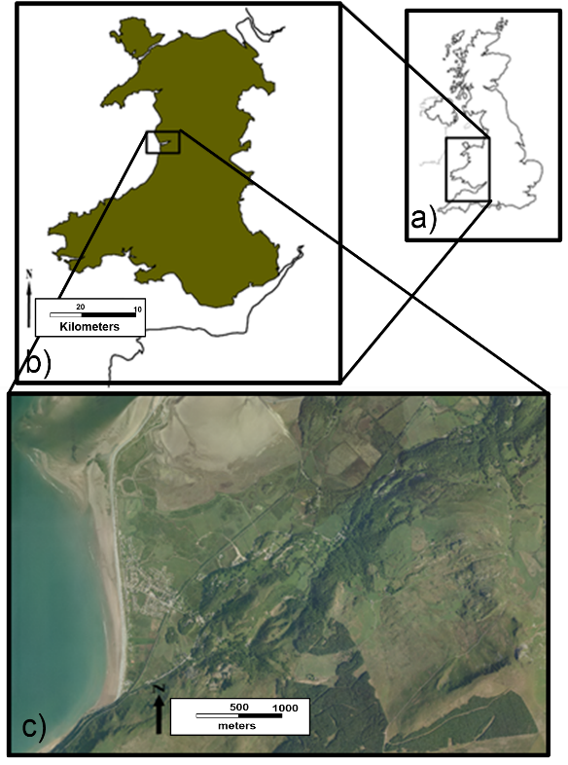
Figure 1. Location of Fairbourne.

It is south of the Mawddach Estuary which developed as a glacial valley that was subsequently flooded by the sea. According to Gwyn and Dutton (1996), Fairbourne was built on a sandy spit projecting into the mouth of the Mawddach with the coastline at that time classified as being stable. South of Friog corner started to erode and avalanche shelters had been constructed over the railway on the cliffs at Friog itself. There are also steep, although not particularly topographically high, hills dropping sharply to coastal level (Gwyn and Dutton, 1996).
Until the second half of the 19th Century Fairbourne was an area of rough open grazing and salt marsh (Hyde, 2013). The arrival of the railway in the 1860s prompted entrepreneurs to develop it as a tourist resort which included a miniature railway and golf-course. Ruins at the end of the promontory appear to date from this time rather than before Barmouth Bridge was built. "Dragon's Teeth" concrete cubes at Fairbourne are impressive remains from the second world-war, and were in good condition in 1996 (Gwyn and Dutton, 1996). Since then, erosion has misaligned many of these near Friog Corner and ongoing erosion led to more sea defences and repair. Further flood defences were planned to protect both the village and nearby SSSI by the Eryri Local Development Plan (Snowdonia National Park, 2016). According to SMP (1998), this section of shoreline is in clear conflict with the marine dynamics with a narrow intertidal zone and clear difficulty in maintaining the coastal works supporting the railway. They identified a need to raise beach levels in the area around Friog Corner and also said the cost effectiveness of sea defences constructed north of the Fairbourne was questionable.

METHODS
Beach profile data from 1992 to 2016 had been seasonally gathered in Spring and Autumn by the local authority which inluded three profiles along the Fairbourne frontage (Figure 2). From these profiles (T23-T25) temporal and spatial data were analysed and it was found that data points varied between surveys in both elevation and spacing.

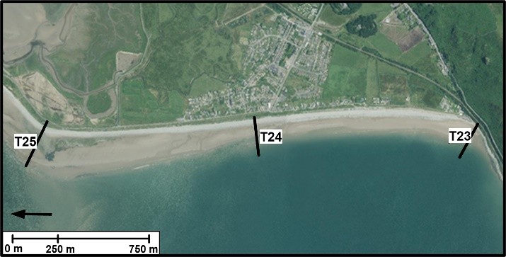
Figure 2. Beach Profiles along the Fairbourne Coastline.

Datasets were subsequently standardised by interpolation to enable effective analysis, with beach levels for each profile determined between a common elevation and seaward extremity (for example Thomas et al., 2015). The common elevation was the Control Point Marker (CPM) and to maximise dataset use, profiles truncated to the CPM were linked to a common offshore contour with sectional volumes directly calculated from the Regional Morphology Analysis Package (RMAP). Here volume is calculated by extrapolating the area under the curve for one unit length (m^{3/}m) of shoreline (see Morang et al., 2009) and two areas were identified for detailed analysis:
- The area between the Control Point Marker and MHWN (Close to the base of the shingle foreshore)
- The area between the CPM and MLWN.

RESULTS
Figure 3 shows the temporal changes at Profile 23, Friog Corner.

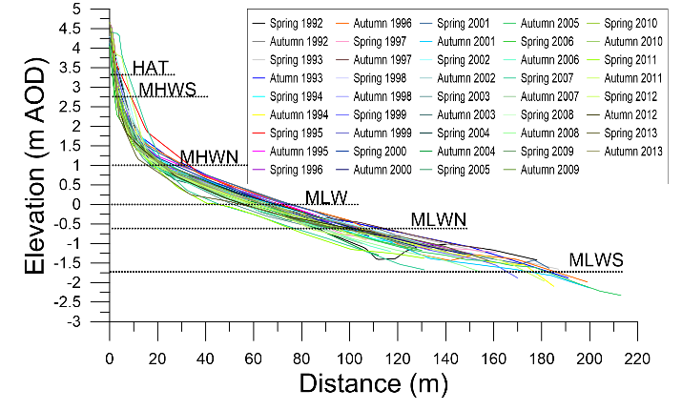
Figure 3. Temporal variation of P23 beach profiles (1992-2013)
Profile 23 volumes were transposed to reflect maximum change in any one-year with analyses indicating that throughout the monitoring period, volumes generally decreased in the shingle bank above MHWN. There were periods of stability during the 1990’s, followed by a relatively consistent loss of material starting around the start of the century that has continued until now. Losses were occasionally offset by quite significant volume increases, possibly associated with beach replenishment following storms, most notably in 1995 and again in 2007, where profile volumes increased by c.32% and c.54% respectively. Overall, between 1992 and 2015, volumes decreased by approximately 31% but replenishment work in 2015 increased volumes to those measured during the early 1990s. Linear trend analysis confirmed losses, given by the equation y = -0.2978x + 621.38. However, the coefficient of determination (R²) only explained c.16% of data variation. Analysis of overall volume change between CPM and MLWN, which includes the sandy foreshore, gives a more consistent pattern of volume decrease, given by y = -1.347x + 2819.5 and an R² value that explained >60% of data variation. There was no apparent correlation between volume change at the shingle bank and the remaining intertidal area to MLWN.
Decreasing volume trends between CPM and both MHWN and MLWN suggests a landward advance which was indeed the case. The 1992-2013 historic beach profile dataset (i.e. prior to the winter 2013-2014 storms) provided a good baseline to assess potential change. However, as data would have to be truncated to the closest tidal contour, the ‘Morphostat’ programme was used (Thomas et al., 2018). This is a semi-automated tool designed to identify changes inside and outside-recorded historic variation and to maximise baseline data use. Essentially, the beach profile envelope is used to develop a statistical approach as follows:
- Individual profile data were interpolated at 1m intervals within RMAP software and imported to ‘Morphostat’.
- Average, maximum, minimum and standard deviation (SD) are calculated based on the 21-year data set (Figure 4).
- Confidence intervals based on 95%ile (+/- 1.96 SD) and 99%ile (+/- 2.33 SD) were calculated for either side of 'average' for each transect (Figure 4).
- Identified Confidence Intervals are colour coded Green, Amber, Red as shown.

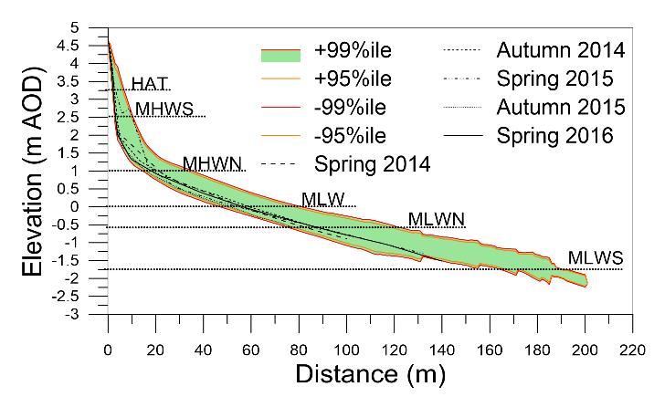
Figure 4. P23 confidence intervals alongside morphological zones

Table1 Profile 23 Morphostat results indicating tidal ladder contours, and general direction of beach level movement.

Table 1: P23 Morphostat Results
Survey Date | ORIGIN to HAT | HAT to MHWS | MHW to MHWN | MHWN to MSL | MSL to MLWN | MLWN to MLWS | OVERALL
S2014
A2014
S2015 |  | ↑ | ↑ |  |  |  | ↑
A2015 |  |  | ↓ |  | ↓ |  | ↓
S2016 |  |  | ↓ |  |  | ↓ | ↓

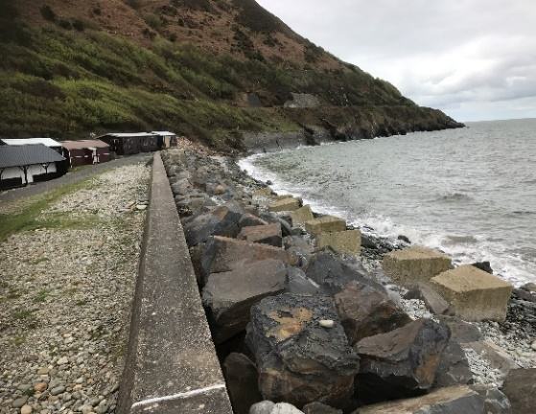
Figure 5. Protection measures and beach profile near Friog Cliffs at the southern end of Fairbourne Village

This profile remained within green status following winter 2013/14 storms, rising to amber status in Spring 2015 then falling to amber status by Spring 2016. The photograph in Figure 5 illustrates the extent of shoreline protection and steepness of this beach profile and the concrete blocks highlight the erosion that has taken place. The P23 Morphostat results, colour-coded for the relevant tidal ladder zone, shows direction of change.

DISCUSSION
Managers should seek to understand and work with natural processes if ICZM plans are to be effective and long lasting. Identification of local characteristics and/or problems and the socio-economic value of resources are vital for effective management. Spatial measures with respect to ICZM should attempt to identify developments that can influence natural shoreline dynamics, whilst temporal analysis should address timeline variation and causal change, for example, climate change. Coastal management initiatives often fail because development impacts are occurring but long-term management strategies are not perceived as relevant in the short-term (Goble et al., 2014). Managing a coastal zone that is subject to a range of unique natural and anthropogenic pressures requires management intervention (Goble et al., 2014). For ICZM to be effective, capacity and understanding is required by government at all levels and all stakeholders, something that was definitely lacking in the case of Fairbourne. The majority of the population of Fairbourne learned their homes were no longer to be defended from a television expose. Immediately after broadcast, it was impossible to sell a property or get a mortgage. Policies will therefore need to reflect the complex inter-relationships of all activities. Therefore, in the case of Fairbourne, the evidence justifying the decision needs to be made available. Global warming and sea level rise are coastal hazards difficult to quantify, but indirect costs will include falling property values and loss or transfer of tourism revenues.
Davies (2014) recognized that it was neither affordable nor sustainable to defend the entire Welsh coast and difficult decisions would have to be taken irrespective of stakeholder interests, but there will be economic consequences (Leatherman, 2001). SMPs are based on limited datasets, which may be insufficient to support strategic decisions such as ‘managed retreat’. Many economic activities take place in the coastal zone and it is often where significant and high value infrastructure is located. Economic well-being of coastal communities is critical and there needs to be greater knowledge and understanding of problems informed by robust data. This is especially true when tourism income is threatened. Policies of ‘managed retreat’ and ‘no active intervention’ at Fairbourne will result in the loss of approximately 400 homes at a conservative cost of £60 million, without taking into consideration business and infrastructure losses and damage to the seaside tourism industry. A final consideration, if the Cambrian railway which passes behind the town of Fairbourne was to become threatened, would ‘hold the line’ be the SMP response? If so, ‘managed retreat’ will only continue to a land-based position where economic importance will change to ‘hold the line’ as perceived more important assets are threatened.

CONCLUSIONS
With climate change and assessments of acceptable risk based on ongoing costs to defend, decisions need to be taken to sustainably manage the shoreline and reduce difficult and expensive decisions for future generations. However, the coastline provides economic opportunities, and tourism is one of the main stakeholders at risk. Therefore, decisions of ‘managed retreat’ and ‘no active intervention’ with no implementation strategy in place, result in economic consequences for coastal stakeholders that do not just include loss of tourism income but also assets and residential properties. Therefore, such decisions should be based on detailed assessments and include costs of lost business and infrastructure.

LITERATURE CITED
Beeharry, Y., Makoondlall-Chadee, T. and Bokhoree, C., 2014. Policy analysis for performance assessment of integrated coastal zone management initiatives for coastal sustainability. APCBEE Procedia, pp. 30–35.
Bremer, S. and Glavovic, B., 2013. Mobilizing knowledge for coastal governance: reframing the science policy interface for integrated coastal management. Coastal Management, 41, 39–56.
Cicin-Sain, B. and Knecht, R.W., 1998. Integrated Coastal and Ocean Management: Concepts and Practices. Island Press, Washington, DC.
Costanza, R., De Groot, R., Sutton, P., van der Ploeg, S., Anderson, S.J., Kubiszewskia, I., Farbere, S. and Turner, R.K., 2014. Changes in the global value of ecosystem services. Global Environmental Change, 26, 152–158.
Davies, A., 2014. Written Statement on Coastal Flooding. Alun Davies (AM) Welsh Government, January, 2014. Available at: http://gov.wales/about/cabinet/cabinetstatement s/previous-administration/2014/coastalflooding/?lang=en (accessed 15 August 2017).
Defra, 2010. United Kingdom Report to the European Commission. Implementation of the ICZM Recommendation 2006–2010. Department for Environment, Food and Rural Affairs, London.
EA (Environment Agency), 2015. Shoreline Management Plan policies – What Do They Mean? Environment Agency. Available at: http://apps.environment-agency.gov.uk/wiyby/134834.aspx (accessed 15 August 2017).
EC (European Commission), 1999. Towards a European Integrated Coastal Zone Management (ICZM) Strategy: General Principles and Policy Options. Office for Official Publications of the European Communities, Luxembourg.
EC (European Commission), 2011. Public Hearing on Integrated Coastal Zone Management 30 May 2011 – Hearing Report. European Commission, Directorate-General Environment.
Glavovic, B.C., 2006. The evolution of coastal management in South Africa: why blood is thicker than water. Ocean Coastal Management, 49(12), 889–904.
Goble, B.J., Lewis, M., Hill, T.R. and Phillips, M.R., 2014. Coastal management in South Africa: historical perspectives and setting the stage of a new era. Ocean and Coastal Management, 91, 32–40.
Gwyn, D.R. and Dutton, L.A., 1996. Coastal Erosion Survey, Aberdaron to Aberdyfi. Gwynedd Archaeological Trust, Report 198.
Jones, A.L. and Phillips, M.R. (eds), 2011. Disappearing Destinations: Climate Change and Future Challenges for Coastal Tourism. CABI International, Wallingford, UK.
Jones, A.L. and Phillips, M.R. (eds), 2018. Global Climate Change and Coastal Tourism: Recognizing problems, managing solutions and future expectations. CABI International, Wallingford, UK.
Leatherman, S.P., 2001. Social and Economic Costs of Sea Level Rise. In: Douglas, B.C., Kearney, M.S. and Leatherman, S.P. (eds) Sea Level Rise – History and Consequences. Academic Press, San Diego, California, pp. 181–223.
Lopez y Royo, C., Silvestri, C., Pergent, G. and Cassazza, G., 2009. Assessing human-induced pressures on coastal areas with publicly available data. Journal of Environmental Management, 90(3), 1494–1501.
Nobre, A., 2011. Scientific approaches to address challenges in coastal management. Marine Ecology Progress Series 434, 279–289.
Phillips, M.R. and Jones, A.L., 2006. Erosion and tourism infrastructure in the coastal zone: problems, consequences and management. Tourism Management, 27(3), 517–524.
Post, J.C. and Lundin, C.G., 1996. Guidelines for Integrated Coastal Zone Management. In: Environmentally Sustainable Development Studies and Monographs Series No. 9, World Bank, Washington, DC.
Royal Haskoning, 2011. West of Wales Shoreline Management Plan 2, Section 4. Coastal Area D. Report No. 9T9001/RSection 4CADv4/303908/PBor.
SBCEG (Swansea Bay Coastal Engineering Group), 1999. Swansea Bay Shoreline Management Plan. Sub-Cell 8b: Worms Head to Lavernock Point. Shoreline Management Partnership and H.R. Wallingford, UK.
Simm, J.D. (ed), 1996. Beach Management Manual. CIRIA Report 153. CIRIA, London. 448pp.
Thomas, T., Phillips, M.R., Morgan, A. and Lock, G., 2018. Morphostat: A simple beach profile-monitoring tool for coastal zone management. Ocean and Coastal Management, 153, 17-32.
Thomas, T., Phillips, M.R. and Lock, G., 2015. An analysis of subaerial beach rotation and influences of environmental forcing adjacent to the proposed Swansea Bay Tidal Lagoon. Applied Geography, 62, 276-293.
UNESCO, 2000. IOC-SOA International workshop on coastal megacities: challenges of growing urbanisation of the World’s coastal areas. In: Intergovernmental Oceanographic Commission Workshop, Report No. 166. Hangzhou
Varghese, K., Ganesh, L.S., Mani, M., Anilkumar P.P., Murthy, R. and Subramaniam, B.R., 2008. Identifying critical variables for coastal profiling in ICZM planning – a systems approach. Ocean and Coastal Management, 51(1), 73–94.
Williams, A.T. and Micallef, A., 2009. Beach Management: Principles and Practice. Earthscan, London.

