

INFORMATION LETTER FOR PARTICIPANTS
The content of ‘information letters for participants’ can be too complex for participants with language and/or communication impairments, such as aphasia (which includes difficulties with spoken and/or written expression and/or comprehension). The National Institute for Health Research (NIHR, UK) has developed resources for stroke researchers with the aim of enabling people with aphasia to participate in research. The research story is an aphasia-friendly information letter for participants. It is not intended to be used in its entirety, but researchers may amend/use any part of it, depending on the particular methodology of the research.

More resources (e.g. more images and templates) and information about using aphasia-friendly writing styles are available on the NIHR website (https://www.nihr.ac.uk/nihr-in-your-area/stroke/aphasia.htm). These resources were produced by researchers together with persons with aphasia themselves.

Should you require further information and/or clarification kindly contact Dr Ritienne Grima, at the Department of Communication Therapy, Faculty of Health Sciences, University of Malta, on ritienne.grima@um.edu.mt.

The research story
What is the research?

   | We are doing some research  It is about stroke and xxxx  Research helps us learn  We need to know more about how to help
- Use the stroke story to broadly explain what happens in a stroke, and then to give information about the aspect of stroke for your research.
- Explain the problem, what question do you want to answer, keep it simple.
- Continue with the details of what will happen in your research. Use the drop down menu for the headings in the template.

Use some of the wording in this section as a starting point. It is not written as a complete story, it is a selection of phrases the user group has found easy to understand. There are examples of how to explain procedures; adapt them as necessary. The examples are a mix of styles and tone to give suggestions of what can be done. The image library may have some of what you need for supporting written explanations about each concept.

Why me?
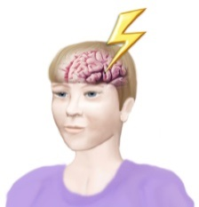  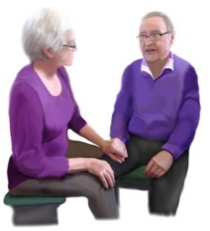 | You have had a stroke  You are a carer of someone who has had a stroke
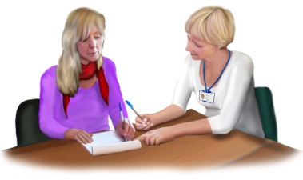 | Your stroke affected your communication  You find it hard to write
 | You had treatment for your stroke in xxxx Hospital

Who is doing the research?
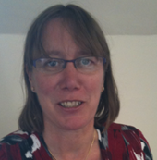  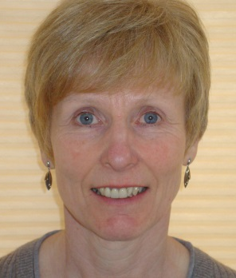    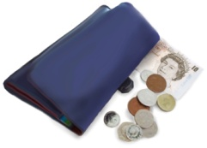 | The manager of this research is  Helen Rodgers  The main researcher is  Gill Pearl  The research is run from the xxx university/hospital  The National Institute for Health Research is paying for this research

Why are we doing the research?
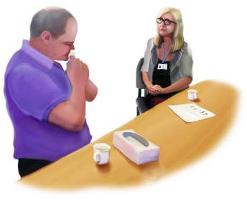   | There is therapy for coping after stroke  Psychologists give this therapy  We don't know enough about it  This research will help us to learn more
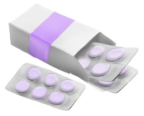     | There is a new drug  This is for shoulder pain after a stroke  We need to test this  We need to know more about it
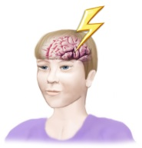 | How can we stop strokes from happening?
  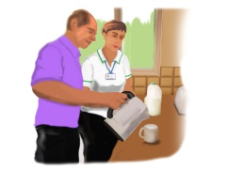  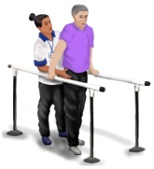 | Research can test new ways to give therapy  We can find out what works best
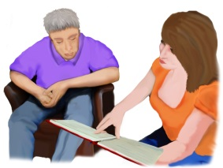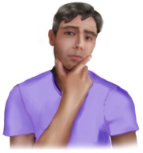  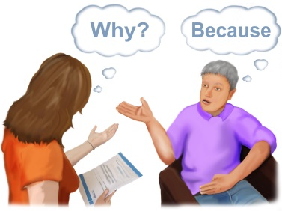 | People get help after a stroke  Can we help people in a better way?  You had help after your stroke   What was good?   What could be improved?
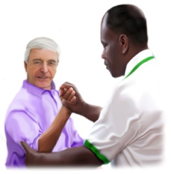   | After a stroke  some people can’t use their hand  It is hard to move the fingers  Occupational therapists may help  They may use a splint  We want to try out a new splint
  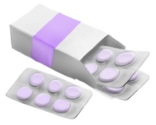  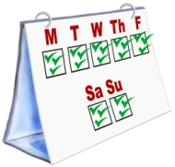  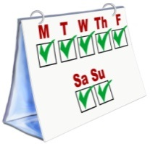 | After a stroke  some people have pain  Medicine can help  Usually the medicine is 3 times a day  We want to know…  Does it work once a day?

What happens in the research?
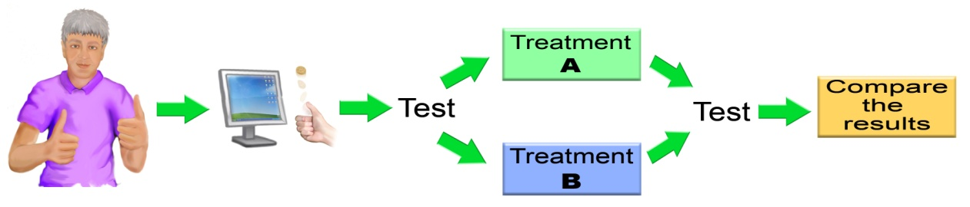
   | There are different ways of giving treatment  We want to compare two different ways  We want to know which is best  Treatment A is xxx  Treatment B is xxx  We want 200 people to take part  Half the people will have treatment A  Half the people will have treatment B  The computer decides  This is like flipping a coin  You would not know which you get  You will have some tests  You will have the treatment  This will last for xxx months/weeks  Then you will have more tests  The researcher will look at the results  They will learn about the treatment
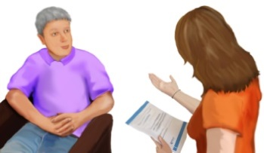     | We want to talk to xxx people  We will ask about xxx after their stroke  We will use what they tell us  Then we will learn more

What will I have to do?
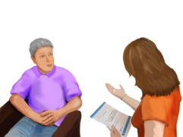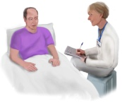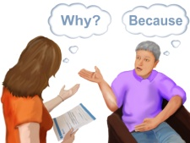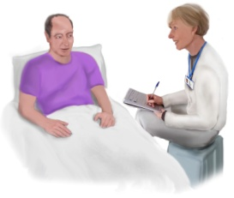    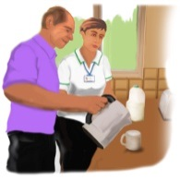    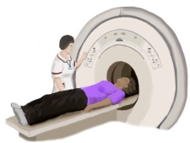      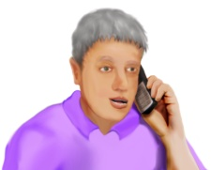   | In the research you will  have an interview  answer some questions  share your opinions and ideas  have some assessments  do some exercises  share your ideas  learn new ways of doing things  use equipment  have some tests  We will give you a questionnaire  We will send you a questionnaire  You can do this at home  Tell us if you need help  We will help you
    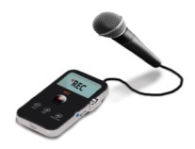  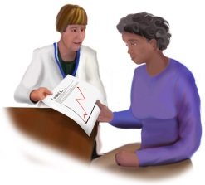   | We will take photographs/video recordings/sound recordings  This helps us to remember what you said  This helps us to measure any change  Only the researchers will see the photographs/video  They will be kept safe

Where will the research happen?
   | The research will happen in several hospitals  These hospitals are in the UK  The research will happen in  Newcastle University
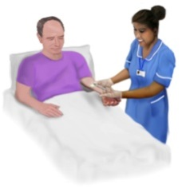  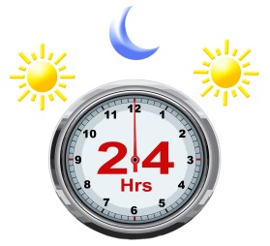 | You will need to stay in hospital for this research  You will stay for 1 day
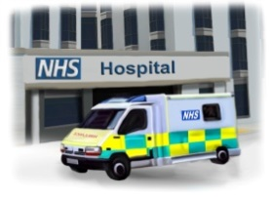 | You will need to visit hospital for the research appointments  You will not stay overnight
 | You will go to a clinic
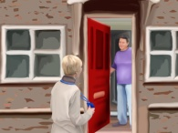 | A researcher will visit you at home
How long will the research last?
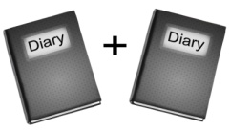   | The whole research will last for xxx years/months  Your part will last for xxx years/months  You will have appointments every xxx/once a week/month

Will I get paid?
     | You will not get paid for taking part in the research  We will pay for your travel to any appointments.  We will pay for any expenses for attending the appointments  We will give you vouchers if you take part  We will give you some money  This is to thank you  Some appointments will last a long time  We will give you meals

Do I have to take part?
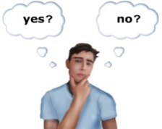   | You can decide  You don't have to  If you don’t take part you will still get your normal help
    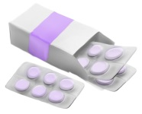 | If you change your mind, you can stop at any time  You don't have to give a reason  If you stop you will still get your normal help
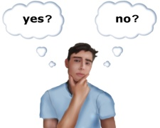    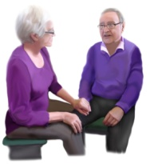 | You don't have to decide now, you can think about it  You can take your time  You can read the information again  You can talk to your family to help you decide
You will need to decide today if you want to take part

This is because xxxx

Who will see the information about me?
 | We will keep the information about you safe  Only the researchers will see the information about you
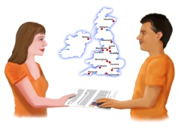 | We may share your information with other researchers in this country  We may share your information with researchers in other countries  This helps with other research about stroke  We will take out your name and personal details
 | We will tell your doctor that you are in this research project


What might be good about taking part?

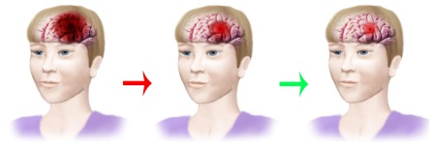 | You may be helped by the therapy/treatment
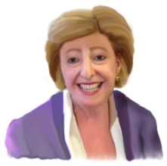 | You may enjoy taking part
 | You may find it interesting
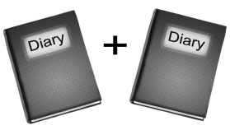 | You will help people in the future  They will get better help
You will help us to learn

This may prevent strokes in the future


What might be difficult about taking part?

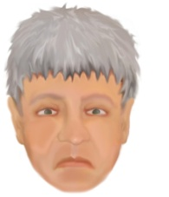 | We don't think it is dangerous  however  the therapy may not help you
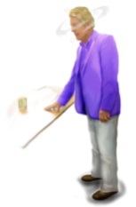 | There may be some side effects
     | You may find it tiring  You may find it distressing  It will take up your time

What if I don't take part in the research?
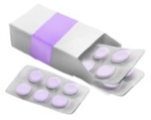  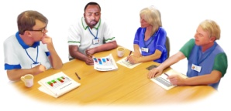 | You will still get your normal help

Is the research safe?
  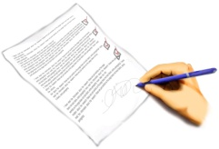 | A committee decides if research can happen  This is the ethics committee  They say that this research can happen  They say that it is safe  They say that it has been planned properly

What if something goes wrong?
This is very unlikely

However,

The NHS has set up a committee

This committee will monitor the research

The committee has different people from those who do this research

  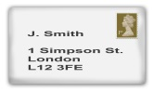     | If you take part in the research  and if you think you were harmed  there are people to talk to  contact xxxxx  at xxxx  The University has insurance

What will happen after the research?
 | The researchers will look at the results
 | They will learn more about xxx

What will happen to the results?
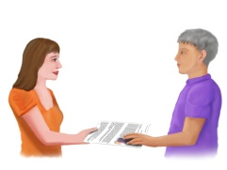 | We will give you the results of the research
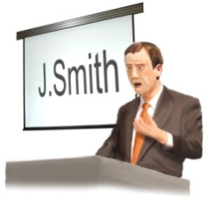    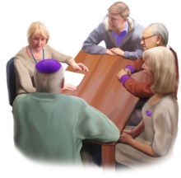 | We will share the results  with other researchers  at conferences and meetings  through newsletters and magazines  in academic journals  on the website xxxx  with other people who have a stroke
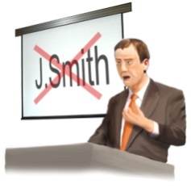 | The results will not use your name
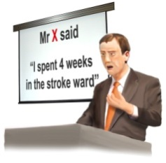 | The results may include what you said  but not who said it
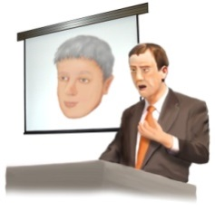 | The results may include photographs of you

What next?
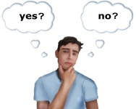 | Do you want to take part?  You need to decide
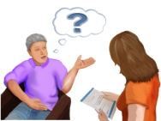  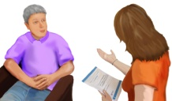 | You may want more information  Contact xxx  They will answer your questions  Let us know if you want to take part  You can contact us at xxxx
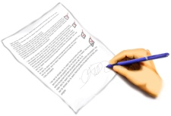  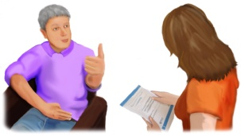 | If you decide to take part  you will need to sign a consent form  This says that you understand the research and you agree to take part
  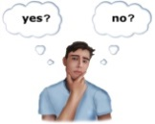     | We will contact you  We will ask for your decision  Yes I want to  No I don't want to
  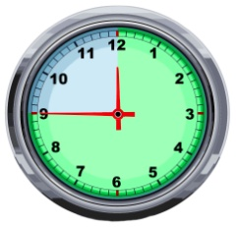 | If you decide to take part  you will have an appointment  This appointment will be in xxx weeks  At this appointment you will xxxx  The appointment will last for xxxx
You will need to bring

a list of your medicines

your splint

your carer

your plan of therapy goals

